The Wrestling Match

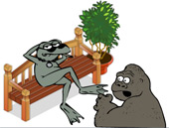
TASK 1
Chimp Andy is expecting you to create a spreadsheet to keep track of all of the seats sold for the wrestling match. He wants you to do some neat spreadsheet stuff such as conditional formatting.

1. Open the spreadsheet called ‘wrestling.xls’

This spreadsheet shows the layout of the wrestling ring and seating area that have been set up in the zoo basement.

The seats have been allocated to the four trusted groups of animals, the lions, the hyenas, the pelicans and the otters.

2. Save this spreadsheet to your area.

3. Using cell A1, add a suitable title to the spreadsheet in Row 1

4. Format the text box so that:
- The font is dark blue
- The background of the text box is light blue – remember, that colour relaxes Chimp Andy
- The font is style: Tahoma
- The font size is 18
- The title is centred within the box

TASK 2
5. Chimp Andy doesn’t read very well – a bit like his boss, Don Corblimey.
Using the internet, find a suitable image of a seal and add it to your spreadsheet. The seal needs to look kind of mean – after all, they are wrestling seals and not the cute little grey ones that the visitors come to coo over.

6. Chimp Andy wants the seating area in the spreadsheet to be colour co-ordinated. He wants to be able to see at a glance which seats have been bought by lions, hyenas, pelicans or otters.

He wants you to use conditional formatting so that the cells automatically change colour depending on what is in them. He says don’t even think about cheating and trying to colour them by hand as he will catch you out later on. If he does catch you, he says you will be in the ring with the seals!

To find out how to set up the conditional formatting go to the next page.
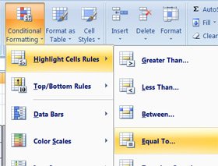
Highlight the cells B4: O17

Go to the home tab

Go to the styles section

Click on Conditional formatting

Choose ‘highlight cells rules’

From the right, choose ‘equal to’

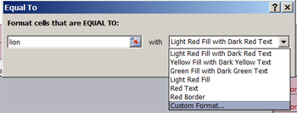
You chose ‘equal to’ because you want it to look for specific text, in this case ‘lion’.

In the box, type: lion

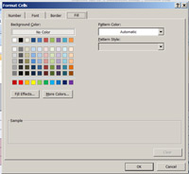
Now you set up the colour background that will show if ‘lion’ is entered into a cell

Click on ‘custom format’

Choose the colour that you want to display when ‘lion’ is contained in a cell.

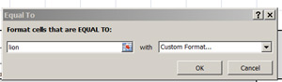
Click ‘ok’

Click ‘ok’

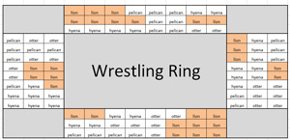

Your spreadsheet should look something like this

Go to a cell that says ‘pelican’ and change it to: lion. You should see that the cell colour changes because it now says lion.

Remember to change that cell back to say ‘pelican’
Do you believe Chimp Andy now when he said he would know if you tried to colour in the cells yourself?

Now you need to set up the conditional formatting for another animal.

Highlight the whole table again.

Go to ‘conditional formatting’
> Home
> Styles
> conditional formatting
> highlight cell rules
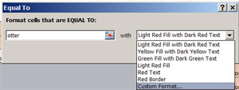
> equal to

This time, type: otter into the box

Choose ‘custom format’

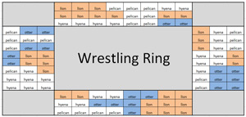
Choose a colour to represent the otters.

Your spreadsheet should now look something like this

Now, complete the conditional formatting for hyenas and pelicans.

TASK 3
You are going to write a COUNTIF function to automatically work out how many tickets were sold to lions, hyenas, pelicans and otters.

You are going to write your first COUNTIF function in cell R4 to show the number of lions.
- Click into R4, start your function off: =COUNTIF
- Open a set of brackets
- Highlight the whole table
- Place a comma after the table range in the function
- Type “lion” into the function
- Close the bracket and press ‘enter’ to complete the function

Now, write your own =COUNTIF function for otters, hyenas and pelicans.

You cannot drag this formula down unless you understand about absolute cell references (we are not going to cover these here).
So for now, you will need to rewrite the COUNTIF function for the other three animals. Chimp Andy is secretly pleased because he wants you to work a bit harder!

You should get the following results:
- Lions 29
- Otters 20
- Hyenas 25
- Pelicans 22

If the number of lions is one extra, remember on task 2 you changed ‘pelican’ to ‘lion’ to check the conditional formatting worked. Did you remember to change it back again?

TASK 4
In cell R8 write a SUM function to add up the total amount of seats that have been sold.

TASK 5
In cell Q9 write AVERAGE
In cell R9 write a function to calculate the average of the numbers in cells: R4:R7

TASK 6 (Extension)
In cell Q10 write ‘Highest’

In cell Q11 write ‘Lowest’

In cell R10 write a MAX function to display the ‘highest’ value in cells R4:R7

In cell R11 write a MIN function to display the ‘lowest’ value in cells R4:R7

TASK 7 (Extension)
Using the data in cells Q4:R7 create a professional looking pie chart. Ensure that % values are displayed.

